Cancer Center Hub Client (CCHC) 1.0

caXchange – ScenPro, Inc.

End User Guide

DOCUMENT CHANGE HISTORY
Version Number | Date | Contributor | Description
1.0 | 2/11/2008 | Anupama Sharma | Initial Draft
1.1 | 2/14/2008 | David Dorman | Reviewed and edited


Updated February 14, 2008

Contact Information
Contacts and Support
NCICB Application Support | http://ncicb.nci.nih.gov/NCICB/support  Telephone: 301-451-4384  Toll free: 888-478-4423

LISTSERV Facilities Pertinent to software teams
LISTSERV | URL | Name

TABLE OF CONTENTS
1. Summary 1
2. Introduction 2
2.1 Overview 2
2.2 Dependencies 2
2.3 Security 2
3. Installation Steps 3
3.1 Zip file 3
4. Application Operation Steps 3
4.1 MAIN Window 3
4.1.1 Main page 3
4.1.2 .CSV to HL7V3 Settings. 4
4.1.3 HL7V2 to HL7V3 Settings 5
4.1.4 Common Settings 6
4.1.5 User Credentials Settings 7
4.1.6 Help Action 8
4.1.7 Accept Action 9
4.1.8 Clear Action 10
4.1.9 Close Action 11
4.2 STATUS WINDOW 12
4.2.1 View Status Logs. 12

Summary
The Cancer Center Hub Client (CCHC) is a stand-alone desktop application. It is used to transform the lab data in the form of .CSV files and HL7V2 messages to HL7V3 message format. These HL7V3 messages are saved in the CTODS database using the Grid Services.

CCHC transformation functions include:
- User sets their transformation preferences.
- CCHC performs the transformation service using these user preferences and by invoking caAdapter APIs.
- CCHC invokes the Grid Service to perform study lookup on a participant to pre-populate study information in the HL7V3 message.
- CCHC saves the generated HL7V3 message into the CTODS database.
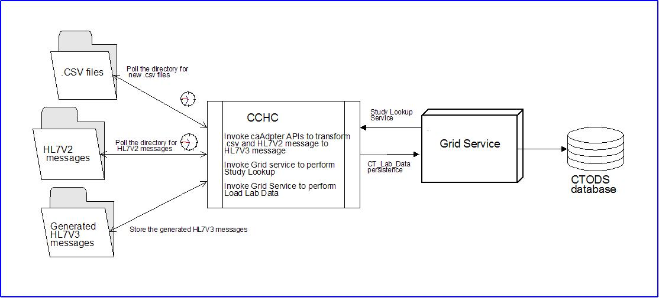
Figure 1Cancer Center Hub Client (CCHC) Message Transformation Process

Introduction

Overview
This user guide identifies and describes the general features and functionality as provided and displayed by CCHC version 1.0. This document has been published to specifically support the use of CCHC.
This document describes the CCHC user interface capabilities and compoenents with screen shots that have been augmented with graphic elements (i.e. boxes, lines, text, etc.). CCHC documentation can be accessed at:
https://gforge.nci.nih.gov/plugins/scmcvs/cvsweb.php/caxchange/?cvsroot=caxchange

Dependencies
The assumptions and dependencies to support the use of CCHC by a user include:
- The CCHC is available for use on an authorized system.
- Current system security protocols are in place and operational.
- The user has access and authorization to use CCHC.

Security
CCHC accesses, displays, and brokers sensitive individually identifiable patient health information. It is the user’s responsibility to ensure that CCHC is used appropriately, to include:
- Exclusively limit the viewing of patient information to authorized personnel only.
- Patient information shall not be released in any form to anyone not directly authorized to view and use the information.
- Patient information will only be searched and displayed for purposes directly related to NCI officially sanctioned tasks and purposes.
- The user shall log out and close the browser at the conclusion of the session.
- The user shall not provide another with their unique user ID and password that is used to access CCHC.

Installation Steps

Zip file
- Download the CAXCHANGECLIENT.zip file.
- Extract it to any folder on your system.
- Open the folder and find run.bat file; double click on the file to start the application.

Application Operation Steps

MAIN Window

Main page
1. Double click on the run.bat file.
2. CCHC main page will display.
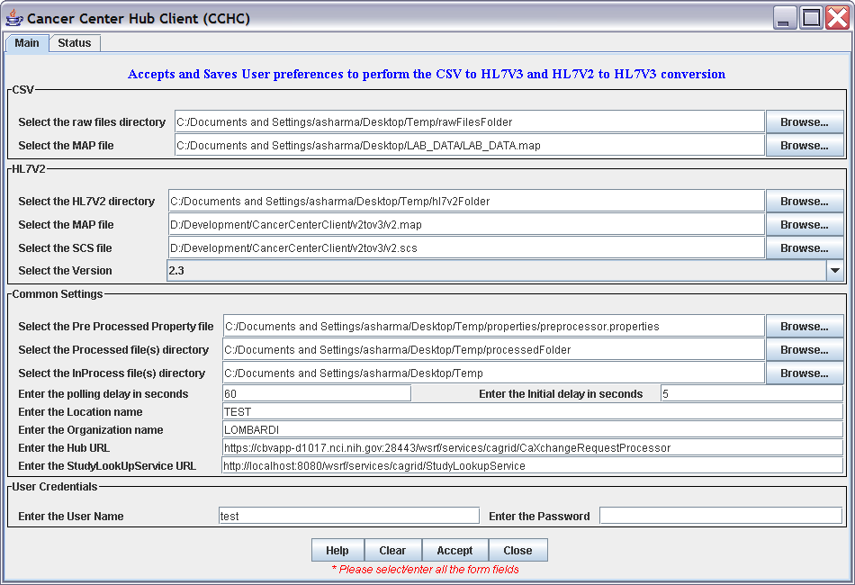
Figure 2 Cancer Center Hub Client (CCHC) Main Page

.CSV to HL7V3 Settings.
- Browse and set the .CSV files directory
- Browse and set the map file used to transform the .CSV file to HL7V3 message.
- Place all the .CSV files to be converted to HL7V3 message under the folder set in “Select the raw files directory”.
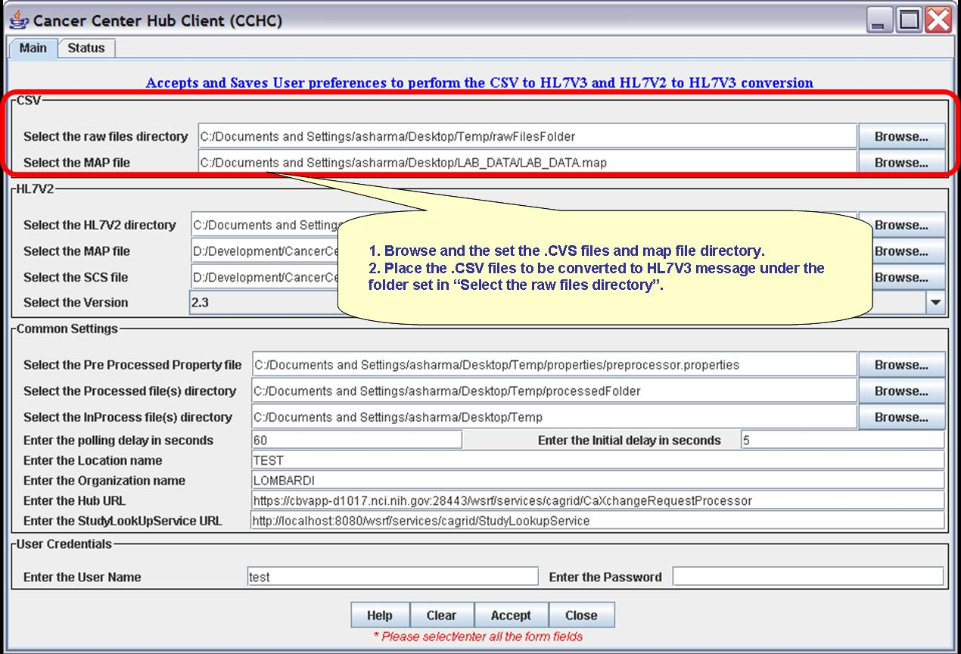
Figure 3 CSV to HL7V3 Transformation Properties

HL7V2 to HL7V3 Settings
- Browse and set the HL7V2 files directory
- Browse and set the map file used to transform the HL7V2 file to HL7V3 message.
- Set the version of the V2Meta to be used for the transformation.
- Place the HL7V2 files to be converted to HL7V3 message under the folder set in “Select the HL7V2 directory”.
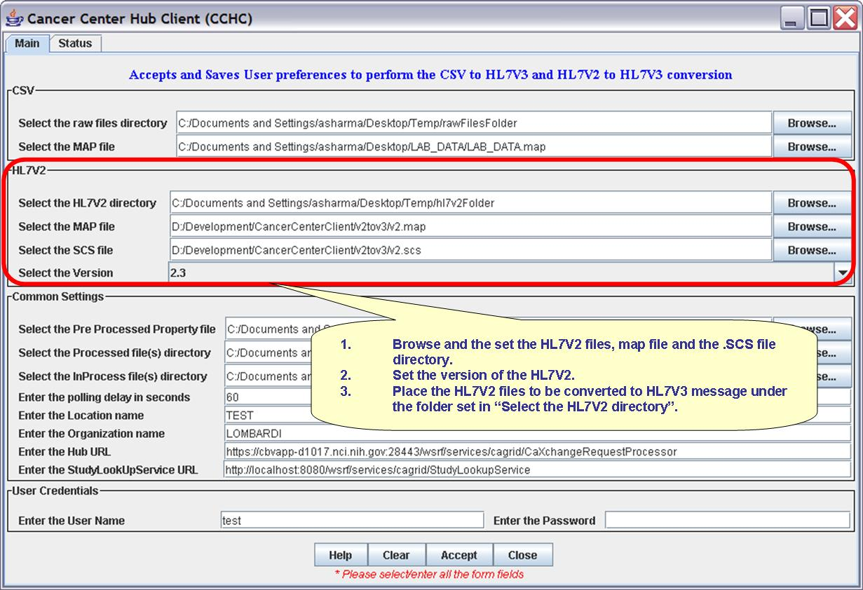
Figure 4 HL7V2 to HL7V3 Transformation Properties

Common Settings
Follow the steps as described below to set the common settings:
- Browse and select the pre-processing properties file.
- Select the folder to put the processed files.
- Select the InProcess directory.
Note: This directory is used to create the InProcess folders like the rawFilesBackup folder, errorFolder. All the files that are processed through the application are stored in the rawFilesBackup folder for future reference. Files that ‘error out’ during the transformation process are moved to the errorFolder.
- Enter the polling interval and the initial polling delay interval.
Note: The unit of interval time is in seconds.
- Enter the Location name.
- Enter the Organization name.
- Enter the Hub URL to load the lab data.
- Enter the Study Lookup Service URL.
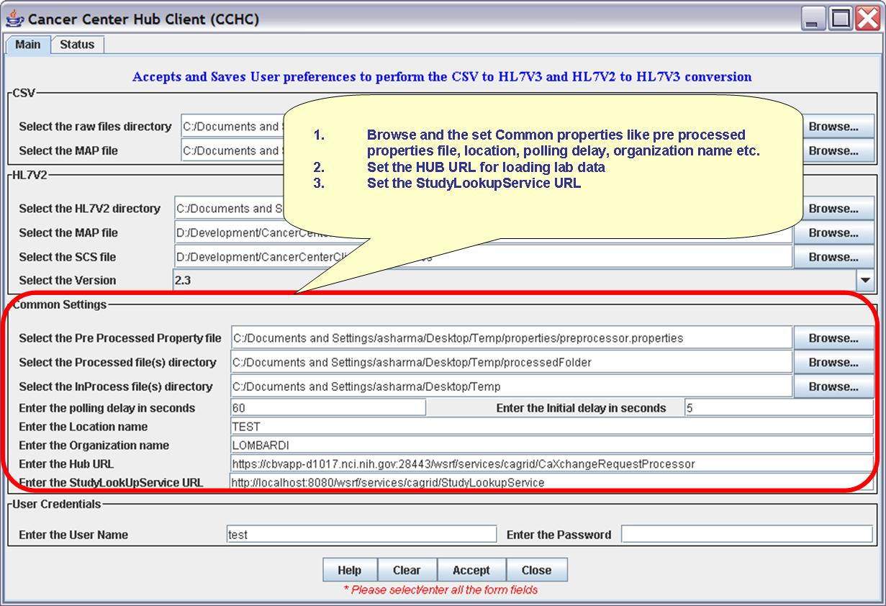
Figure 5 Common Transformation Properties

User Credentials Settings
- Enter the user credentials –username and password.
Note: This is used to check if the user is authorized to send request to load lab data and to perform lookup service using the Grid Service. Currently this feature is disabled.
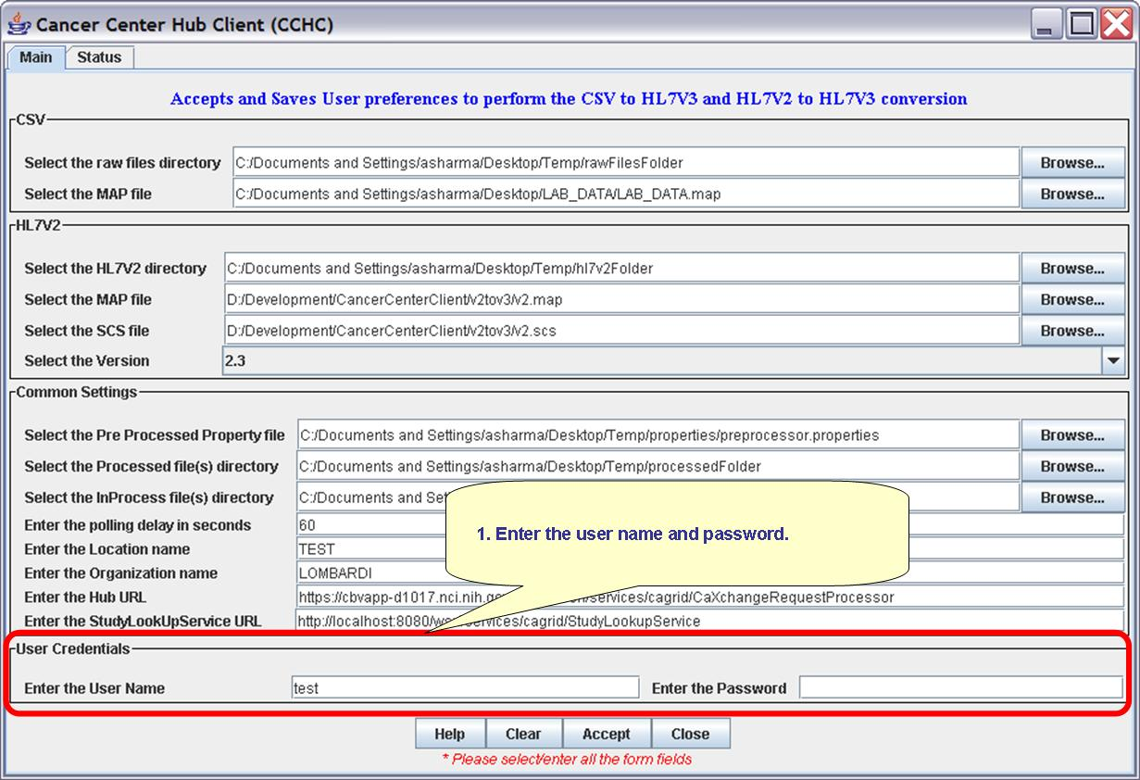
Figure 6 User Credential Settings

Help Action
- Selecting/Clicking the Help button will open the CCHC End User Manual.
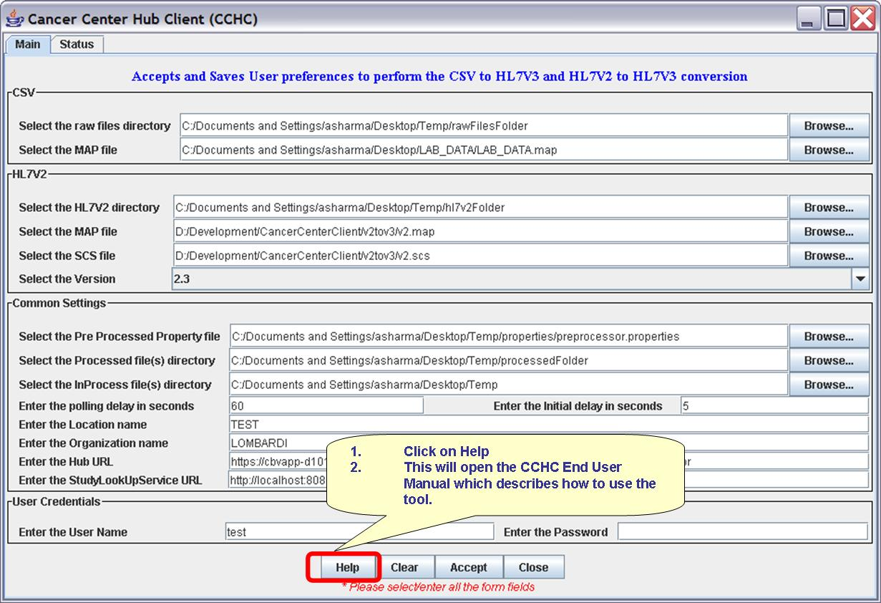
Figure 7 Access Help

Accept Action
- Selecting/Clicking the Accept Button will save the user preferences into a properties file
Note: The properties file can be accessed and modified in the future. The properties file gets saved in the properties directory under the zip file extracted folder.
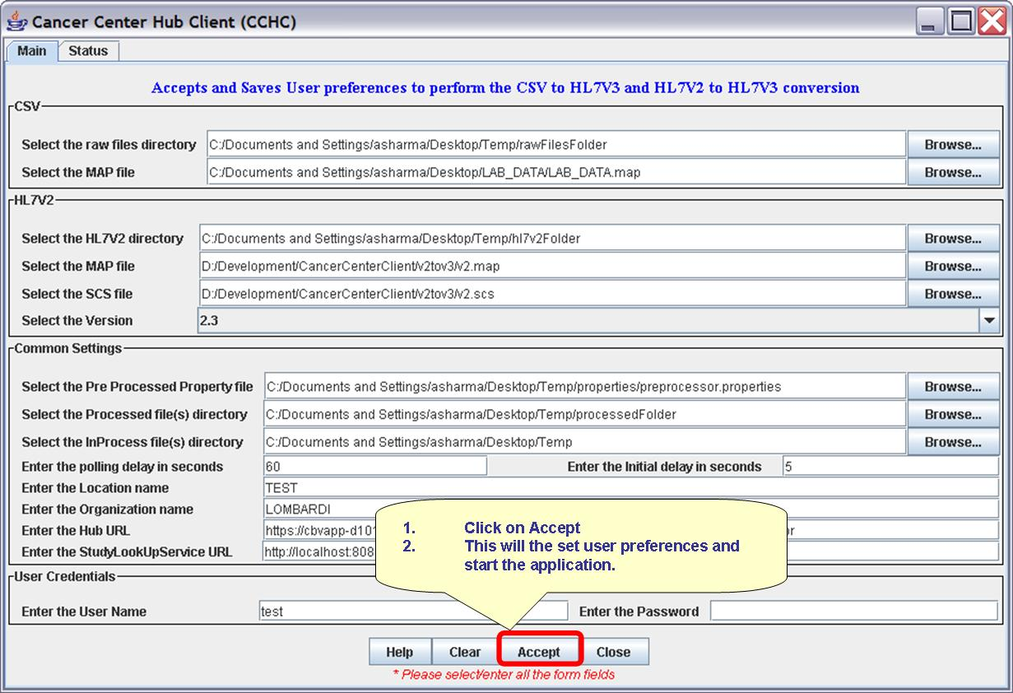
Figure 8 Accept Transformation

Clear Action
- Selecting/Clicking the Clear Button will clear all the fields and user settings.
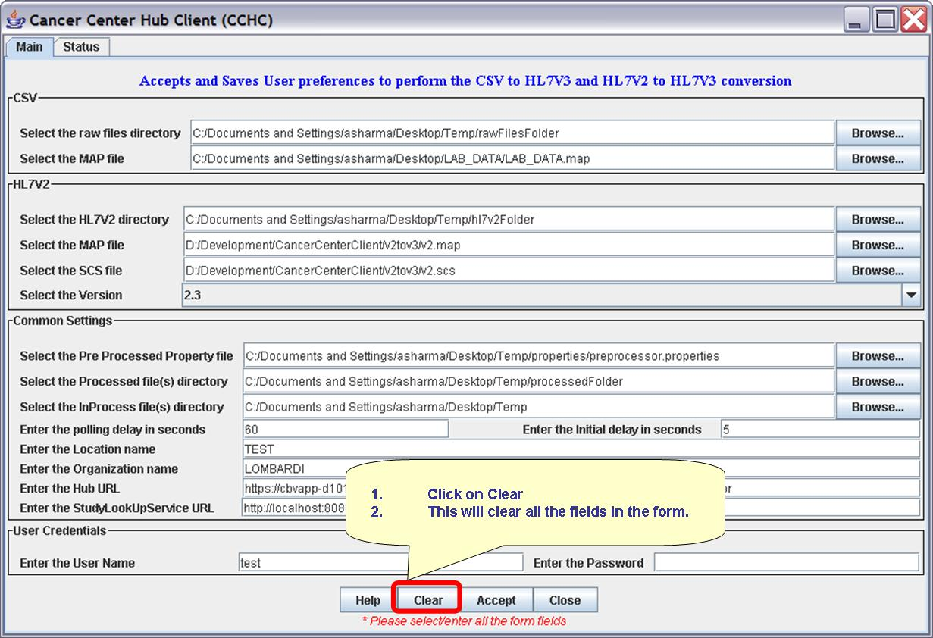
Figure 9 Clear Action Feature

Close Action
- Selecting/Clicking the Close button will close the GUI and stop the process of polling the directories for new .CSV files and HL7V2 files.
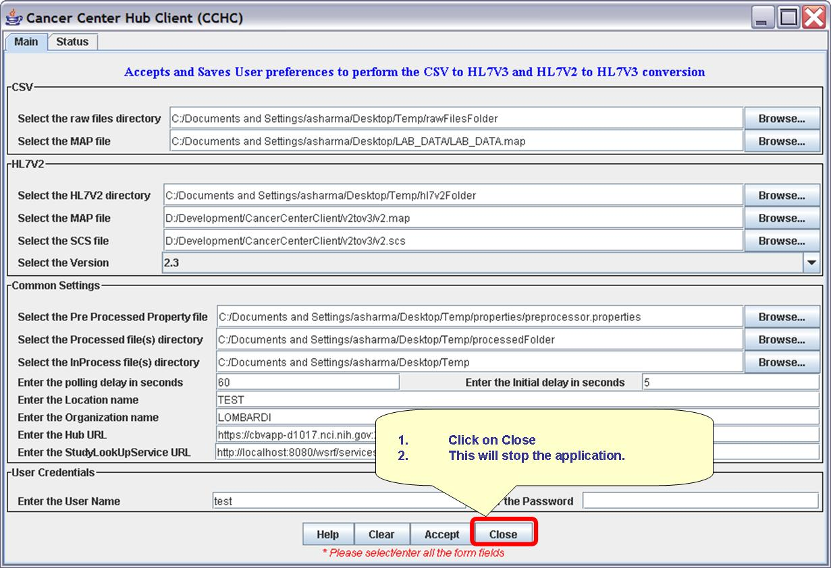
Figure 10 Close Application

STATUS WINDOW

View Status Logs.
- Select the Status tab to view status data.
Note: The status screen displays the log messages from the application. The log file is saved under the log directory in the zip file extracted folder.
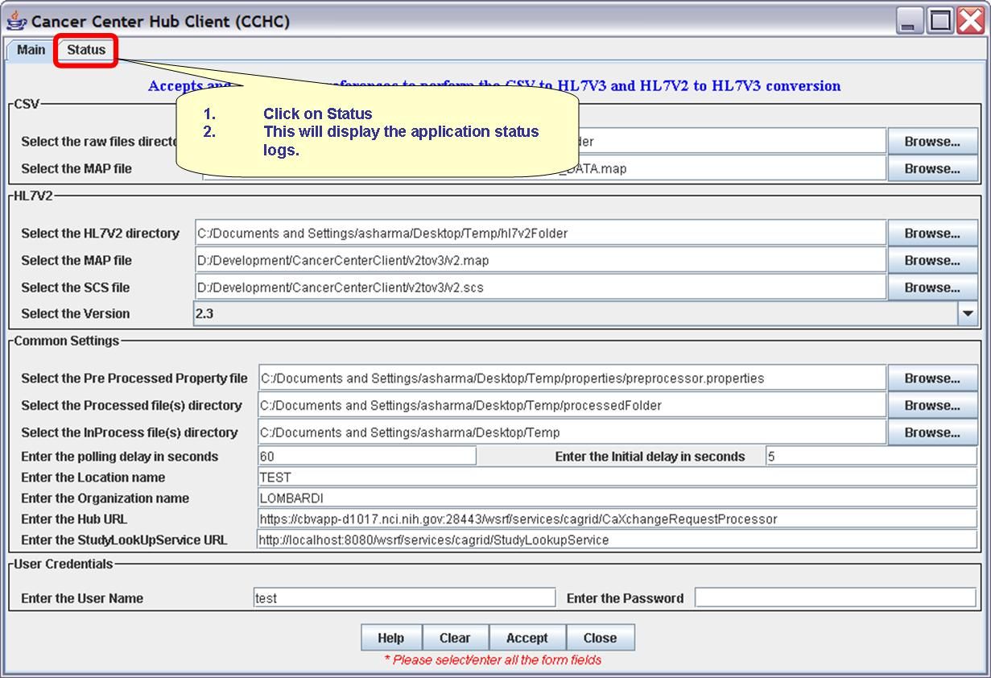
Figure 11 Status Tab

- The status window displays.
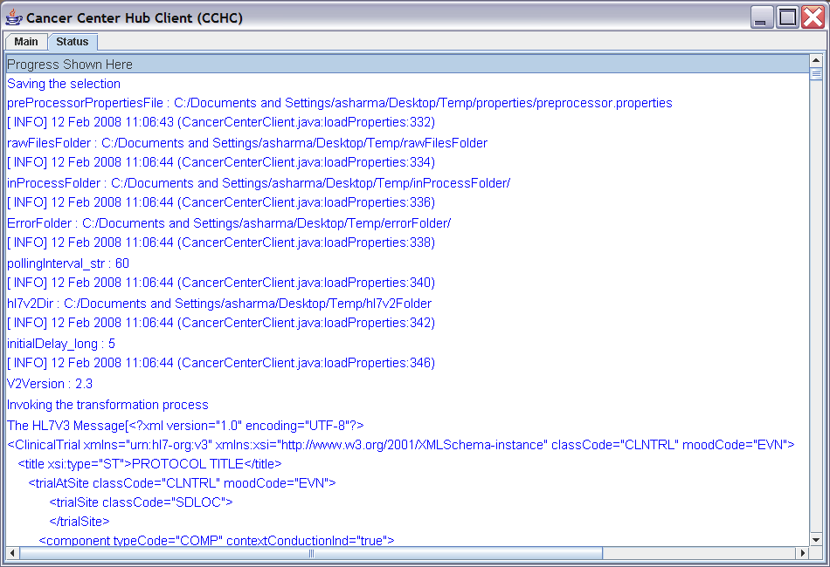
Figure 12 Status Window

